hate as nooff

alpha=2

1 run......

training 1 epoch...

95.67051243782043 seconds used......

1 training finished! average train loss: 1.5022512582215395

total clf loss: 146.38744789361954 total adv loss: 92.05391468852758

evaluating...

Confusion matrix, without normalization

[[ 32 68 90]

[ 15 305 95]

[ 18 28 667]]

Normalized confusion matrix

[[0.16842105 0.35789474 0.47368421]

[0.03614458 0.73493976 0.22891566]

[0.02524544 0.03927069 0.93548387]]

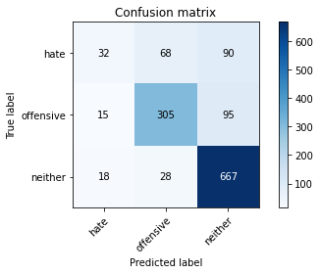

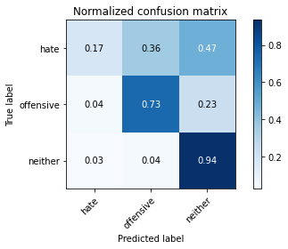

precision recall f1-score support

hate 0.49 0.17 0.25 190

offensive 0.76 0.73 0.75 415

neither 0.78 0.94 0.85 713

accuracy 0.76 1318

macro avg 0.68 0.61 0.62 1318

weighted avg 0.73 0.76 0.73 1318

average eval_loss: 0.5803445225412195, accuracy: 0.7617602427921093

training 2 epoch...

95.68450832366943 seconds used......

2 training finished! average train loss: 1.0587010077454828

total clf loss: 105.15262056142092 total adv loss: 63.88080083951354

evaluating...

Confusion matrix, without normalization

[[ 52 89 49]

[ 29 359 27]

[ 51 99 563]]

Normalized confusion matrix

[[0.27368421 0.46842105 0.25789474]

[0.06987952 0.86506024 0.06506024]

[0.07152875 0.13884993 0.78962132]]

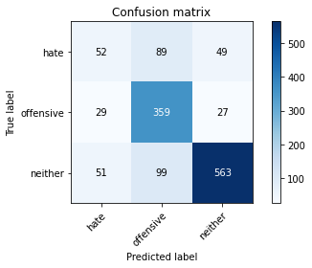

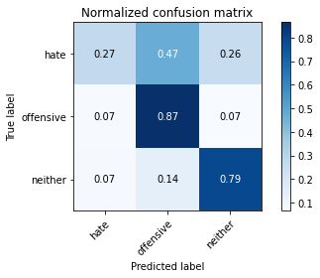

precision recall f1-score support

hate 0.39 0.27 0.32 190

offensive 0.66 0.87 0.75 415

neither 0.88 0.79 0.83 713

accuracy 0.74 1318

macro avg 0.64 0.64 0.63 1318

weighted avg 0.74 0.74 0.73 1318

average eval_loss: 0.6328975495063898, accuracy: 0.7389984825493171

training 3 epoch...

95.65264701843262 seconds used......

3 training finished! average train loss: 0.7472787206484512

total clf loss: 77.43795194663107 total adv loss: 43.48168313130736

evaluating...

Confusion matrix, without normalization

[[ 80 67 43]

[ 56 320 39]

[ 90 56 567]]

Normalized confusion matrix

[[0.42105263 0.35263158 0.22631579]

[0.13493976 0.77108434 0.0939759 ]

[0.12622721 0.07854137 0.79523142]]

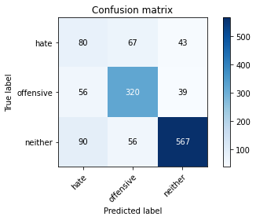

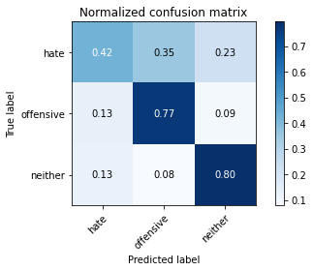

precision recall f1-score support

hate 0.35 0.42 0.38 190

offensive 0.72 0.77 0.75 415

neither 0.87 0.80 0.83 713

accuracy 0.73 1318

macro avg 0.65 0.66 0.65 1318

weighted avg 0.75 0.73 0.74 1318

average eval_loss: 0.6707022962245074, accuracy: 0.7336874051593323

training 4 epoch...

95.69925498962402 seconds used......

4 training finished! average train loss: 0.40273892710578035

total clf loss: 47.51851265318692 total adv loss: 20.54202586491556

evaluating...

Confusion matrix, without normalization

[[ 76 74 40]

[ 49 334 32]

[106 68 539]]

Normalized confusion matrix

[[0.4 0.38947368 0.21052632]

[0.11807229 0.80481928 0.07710843]

[0.1486676 0.09537167 0.75596073]]

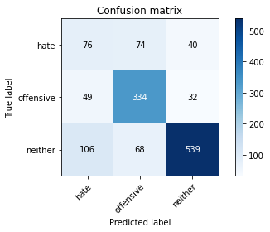

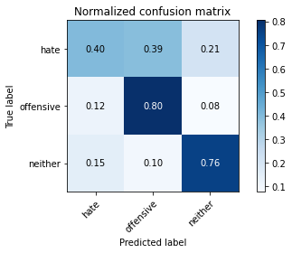

precision recall f1-score support

hate 0.33 0.40 0.36 190

offensive 0.70 0.80 0.75 415

neither 0.88 0.76 0.81 713

accuracy 0.72 1318

macro avg 0.64 0.65 0.64 1318

weighted avg 0.75 0.72 0.73 1318

average eval_loss: 0.8547744425860319, accuracy: 0.720030349013657

training 5 epoch...

95.71754121780396 seconds used......

5 training finished! average train loss: 0.25794498205015604

total clf loss: 32.826972055248916 total adv loss: 11.960462032438954

evaluating...

Confusion matrix, without normalization

[[ 54 66 70]

[ 47 306 62]

[ 73 41 599]]

Normalized confusion matrix

[[0.28421053 0.34736842 0.36842105]

[0.11325301 0.7373494 0.14939759]

[0.10238429 0.05750351 0.8401122 ]]

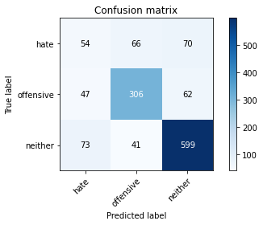

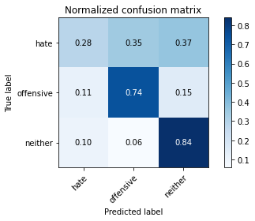

precision recall f1-score support

hate 0.31 0.28 0.30 190

offensive 0.74 0.74 0.74 415

neither 0.82 0.84 0.83 713

accuracy 0.73 1318

macro avg 0.62 0.62 0.62 1318

weighted avg 0.72 0.73 0.72 1318

average eval_loss: 0.935791727719885, accuracy: 0.7276176024279211

training 6 epoch...

95.69079303741455 seconds used......

6 training finished! average train loss: 0.18623970483048735

total clf loss: 22.375734001398087 total adv loss: 9.298500480796065

evaluating...

Confusion matrix, without normalization

[[ 86 65 39]

[ 64 315 36]

[129 56 528]]

Normalized confusion matrix

[[0.45263158 0.34210526 0.20526316]

[0.15421687 0.75903614 0.08674699]

[0.18092567 0.07854137 0.74053296]]

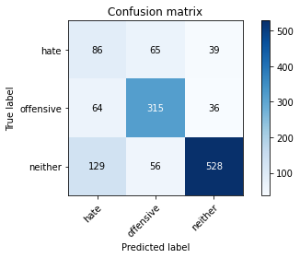

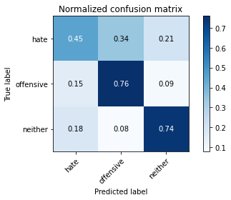

precision recall f1-score support

hate 0.31 0.45 0.37 190

offensive 0.72 0.76 0.74 415

neither 0.88 0.74 0.80 713

accuracy 0.70 1318

macro avg 0.64 0.65 0.64 1318

weighted avg 0.75 0.70 0.72 1318

average eval_loss: 1.026494517470851, accuracy: 0.704855842185129

training 7 epoch...

95.74478960037231 seconds used......

7 training finished! average train loss: 0.10384864189968952

total clf loss: 13.878712595324032 total adv loss: 4.483994311087372

evaluating...

Confusion matrix, without normalization

[[ 60 80 50]

[ 32 337 46]

[ 72 73 568]]

Normalized confusion matrix

[[0.31578947 0.42105263 0.26315789]

[0.07710843 0.81204819 0.11084337]

[0.10098177 0.10238429 0.79663394]]

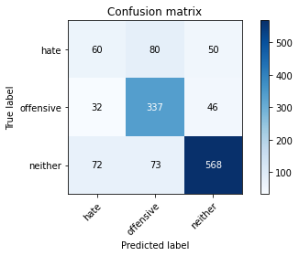

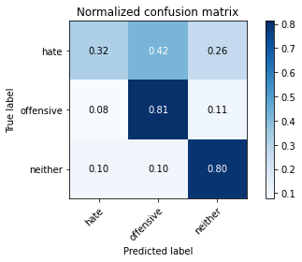

precision recall f1-score support

hate 0.37 0.32 0.34 190

offensive 0.69 0.81 0.74 415

neither 0.86 0.80 0.82 713

accuracy 0.73 1318

macro avg 0.64 0.64 0.64 1318

weighted avg 0.73 0.73 0.73 1318

average eval_loss: 1.203748380144437, accuracy: 0.7321699544764795

training 8 epoch...

95.75945496559143 seconds used......

8 training finished! average train loss: 0.1012458820308728

total clf loss: 10.764592436142266 total adv loss: 5.7547508245647805

evaluating...

Confusion matrix, without normalization

[[ 59 86 45]

[ 45 332 38]

[102 65 546]]

Normalized confusion matrix

[[0.31052632 0.45263158 0.23684211]

[0.10843373 0.8 0.09156627]

[0.1430575 0.0911641 0.7657784 ]]

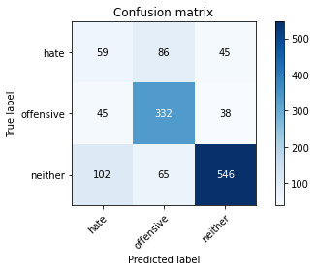

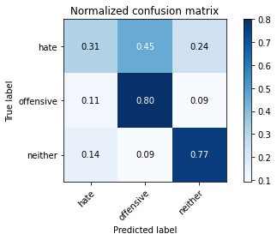

precision recall f1-score support

hate 0.29 0.31 0.30 190

offensive 0.69 0.80 0.74 415

neither 0.87 0.77 0.81 713

accuracy 0.71 1318

macro avg 0.61 0.63 0.62 1318

weighted avg 0.73 0.71 0.72 1318

average eval_loss: 1.314646858609084, accuracy: 0.7109256449165402

training 9 epoch...

95.65523552894592 seconds used......

9 training finished! average train loss: 0.06516988017617471

total clf loss: 7.64582508278545 total adv loss: 3.345774264101692

evaluating...

Confusion matrix, without normalization

[[ 69 84 37]

[ 55 322 38]

[140 56 517]]

Normalized confusion matrix

[[0.36315789 0.44210526 0.19473684]

[0.13253012 0.77590361 0.09156627]

[0.19635344 0.07854137 0.72510519]]

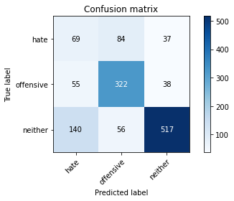

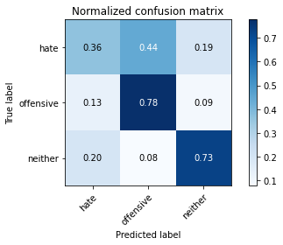

precision recall f1-score support

hate 0.26 0.36 0.30 190

offensive 0.70 0.78 0.73 415

neither 0.87 0.73 0.79 713

accuracy 0.69 1318

macro avg 0.61 0.62 0.61 1318

weighted avg 0.73 0.69 0.70 1318

average eval_loss: 1.4094441022836801, accuracy: 0.6889226100151745

training 10 epoch...

95.65104413032532 seconds used......

10 training finished! average train loss: 0.06159708573303016

total clf loss: 6.346511085997918 total adv loss: 3.6024239658108854

evaluating...

Confusion matrix, without normalization

[[ 75 77 38]

[ 58 325 32]

[137 55 521]]

Normalized confusion matrix

[[0.39473684 0.40526316 0.2 ]

[0.13975904 0.78313253 0.07710843]

[0.19214586 0.07713885 0.73071529]]

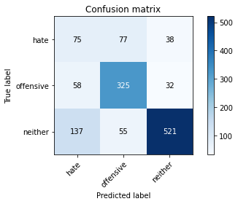

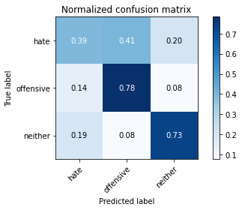

precision recall f1-score support

hate 0.28 0.39 0.33 190

offensive 0.71 0.78 0.75 415

neither 0.88 0.73 0.80 713

accuracy 0.70 1318

macro avg 0.62 0.64 0.62 1318

weighted avg 0.74 0.70 0.71 1318

average eval_loss: 1.4882451765465015, accuracy: 0.6987860394537178

2 run......

training 1 epoch...

95.6813850402832 seconds used......

1 training finished! average train loss: 1.484696612388573

total clf loss: 144.47167329862714 total adv loss: 91.08079058676958

evaluating...

Confusion matrix, without normalization

[[ 33 99 58]

[ 18 355 42]

[ 32 90 591]]

Normalized confusion matrix

[[0.17368421 0.52105263 0.30526316]

[0.04337349 0.85542169 0.10120482]

[0.04488079 0.12622721 0.82889201]]

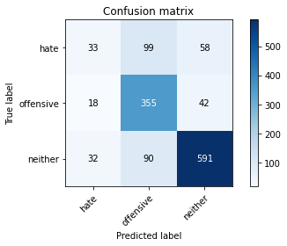

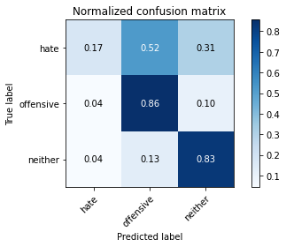

precision recall f1-score support

hate 0.40 0.17 0.24 190

offensive 0.65 0.86 0.74 415

neither 0.86 0.83 0.84 713

accuracy 0.74 1318

macro avg 0.64 0.62 0.61 1318

weighted avg 0.73 0.74 0.72 1318

average eval_loss: 0.6280475985823255, accuracy: 0.7427921092564491

training 2 epoch...

95.76144790649414 seconds used......

2 training finished! average train loss: 1.0636520095846869

total clf loss: 105.62919500470161 total adv loss: 64.18712329491973

evaluating...

Confusion matrix, without normalization

[[ 61 87 42]

[ 34 351 30]

[112 77 524]]

Normalized confusion matrix

[[0.32105263 0.45789474 0.22105263]

[0.08192771 0.84578313 0.07228916]

[0.15708275 0.10799439 0.73492286]]

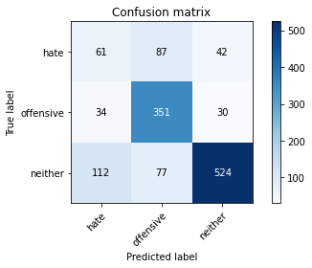

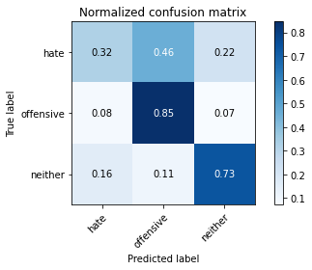

precision recall f1-score support

hate 0.29 0.32 0.31 190

offensive 0.68 0.85 0.75 415

neither 0.88 0.73 0.80 713

accuracy 0.71 1318

macro avg 0.62 0.63 0.62 1318

weighted avg 0.73 0.71 0.72 1318

average eval_loss: 0.6992554601394769, accuracy: 0.7101669195751138

training 3 epoch...

95.8169355392456 seconds used......

3 training finished! average train loss: 0.6975397829006066

total clf loss: 74.17594904871657 total adv loss: 39.6414015919072

evaluating...

Confusion matrix, without normalization

[[ 69 59 62]

[ 39 310 66]

[ 61 47 605]]

Normalized confusion matrix

[[0.36315789 0.31052632 0.32631579]

[0.0939759 0.74698795 0.15903614]

[0.085554 0.06591865 0.84852735]]

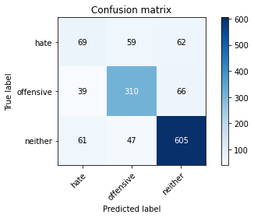

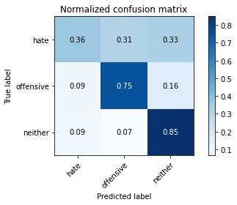

precision recall f1-score support

hate 0.41 0.36 0.38 190

offensive 0.75 0.75 0.75 415

neither 0.83 0.85 0.84 713

accuracy 0.75 1318

macro avg 0.66 0.65 0.66 1318

weighted avg 0.74 0.75 0.74 1318

average eval_loss: 0.6801959366509409, accuracy: 0.7465857359635811

training 4 epoch...

95.77210879325867 seconds used......

4 training finished! average train loss: 0.3747399758378213

total clf loss: 46.08553772047162 total adv loss: 18.178628365509212

evaluating...

Confusion matrix, without normalization

[[ 46 91 53]

[ 21 347 47]

[ 43 88 582]]

Normalized confusion matrix

[[0.24210526 0.47894737 0.27894737]

[0.05060241 0.83614458 0.11325301]

[0.06030856 0.12342216 0.81626928]]

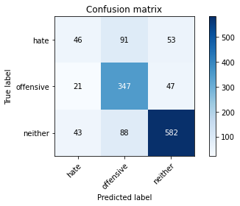

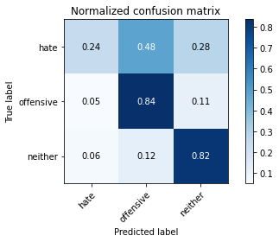

precision recall f1-score support

hate 0.42 0.24 0.31 190

offensive 0.66 0.84 0.74 415

neither 0.85 0.82 0.83 713

accuracy 0.74 1318

macro avg 0.64 0.63 0.63 1318

weighted avg 0.73 0.74 0.73 1318

average eval_loss: 0.9334317048390707, accuracy: 0.7397572078907435

training 5 epoch...

95.81802797317505 seconds used......

5 training finished! average train loss: 0.2576460568064993

total clf loss: 32.05394744640216 total adv loss: 12.314092495376826

evaluating...

Confusion matrix, without normalization

[[ 46 85 59]

[ 32 323 60]

[ 62 61 590]]

Normalized confusion matrix

[[0.24210526 0.44736842 0.31052632]

[0.07710843 0.77831325 0.14457831]

[0.08695652 0.085554 0.82748948]]

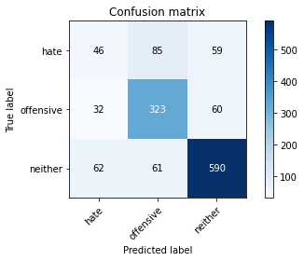

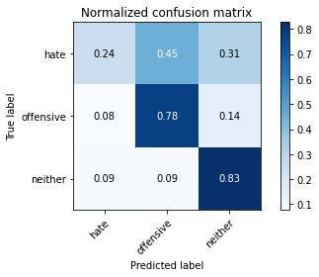

precision recall f1-score support

hate 0.33 0.24 0.28 190

offensive 0.69 0.78 0.73 415

neither 0.83 0.83 0.83 713

accuracy 0.73 1318

macro avg 0.62 0.62 0.61 1318

weighted avg 0.71 0.73 0.72 1318

average eval_loss: 0.9290897792035883, accuracy: 0.7276176024279211

training 6 epoch...

95.78489208221436 seconds used......

6 training finished! average train loss: 0.1804196866610172

total clf loss: 21.38949577603489 total adv loss: 9.151417649212817

evaluating...

Confusion matrix, without normalization

[[ 54 88 48]

[ 32 339 44]

[ 96 72 545]]

Normalized confusion matrix

[[0.28421053 0.46315789 0.25263158]

[0.07710843 0.81686747 0.1060241 ]

[0.13464236 0.10098177 0.76437588]]

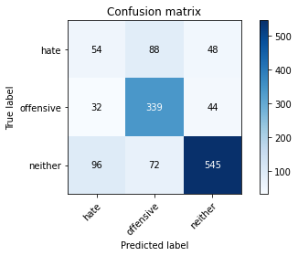

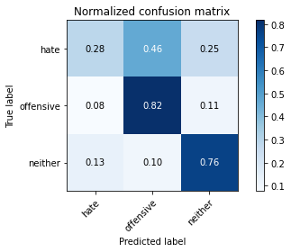

precision recall f1-score support

hate 0.30 0.28 0.29 190

offensive 0.68 0.82 0.74 415

neither 0.86 0.76 0.81 713

accuracy 0.71 1318

macro avg 0.61 0.62 0.61 1318

weighted avg 0.72 0.71 0.71 1318

average eval_loss: 1.1517470406763481, accuracy: 0.7116843702579666

training 7 epoch...

95.80083918571472 seconds used......

7 training finished! average train loss: 0.11326803962451364

total clf loss: 13.029877696419135 total adv loss: 5.9445454529850394

evaluating...

Confusion matrix, without normalization

[[ 38 107 45]

[ 23 350 42]

[ 80 108 525]]

Normalized confusion matrix

[[0.2 0.56315789 0.23684211]

[0.05542169 0.84337349 0.10120482]

[0.11220196 0.15147265 0.73632539]]

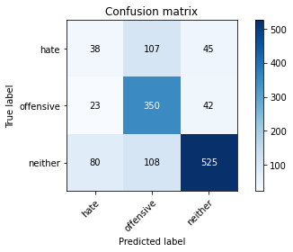

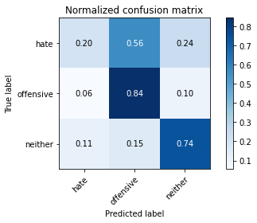

precision recall f1-score support

hate 0.27 0.20 0.23 190

offensive 0.62 0.84 0.71 415

neither 0.86 0.74 0.79 713

accuracy 0.69 1318

macro avg 0.58 0.59 0.58 1318

weighted avg 0.70 0.69 0.69 1318

average eval_loss: 1.3575287235505653, accuracy: 0.6927162367223065

training 8 epoch...

95.83295059204102 seconds used......

8 training finished! average train loss: 0.06544467308346859

total clf loss: 8.192984967725351 total adv loss: 3.1024215409688622

evaluating...

Confusion matrix, without normalization

[[ 61 81 48]

[ 44 321 50]

[110 56 547]]

Normalized confusion matrix

[[0.32105263 0.42631579 0.25263158]

[0.1060241 0.77349398 0.12048193]

[0.1542777 0.07854137 0.76718093]]

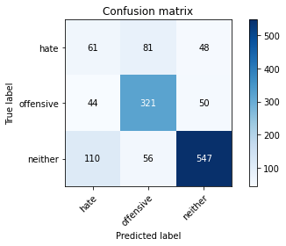

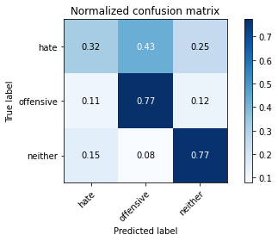

precision recall f1-score support

hate 0.28 0.32 0.30 190

offensive 0.70 0.77 0.74 415

neither 0.85 0.77 0.81 713

accuracy 0.70 1318

macro avg 0.61 0.62 0.61 1318

weighted avg 0.72 0.70 0.71 1318

average eval_loss: 1.2491490592559178, accuracy: 0.704855842185129

training 9 epoch...

95.71032166481018 seconds used......

9 training finished! average train loss: 0.05481243849472693

total clf loss: 6.823456192447338 total adv loss: 2.617640134748399

evaluating...

Confusion matrix, without normalization

[[ 82 62 46]

[ 64 301 50]

[116 45 552]]

Normalized confusion matrix

[[0.43157895 0.32631579 0.24210526]

[0.15421687 0.7253012 0.12048193]

[0.16269285 0.0631136 0.77419355]]

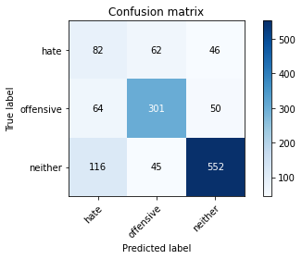

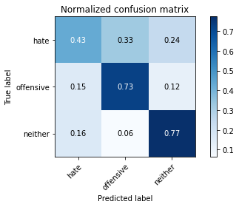

precision recall f1-score support

hate 0.31 0.43 0.36 190

offensive 0.74 0.73 0.73 415

neither 0.85 0.77 0.81 713

accuracy 0.71 1318

macro avg 0.63 0.64 0.64 1318

weighted avg 0.74 0.71 0.72 1318

average eval_loss: 1.2648360047376517, accuracy: 0.7094081942336874

training 10 epoch...

95.74093127250671 seconds used......

10 training finished! average train loss: 0.04929722240538632

total clf loss: 6.097983291372657 total adv loss: 2.373702804829577

evaluating...

Confusion matrix, without normalization

[[ 70 82 38]

[ 56 317 42]

[134 66 513]]

Normalized confusion matrix

[[0.36842105 0.43157895 0.2 ]

[0.13493976 0.76385542 0.10120482]

[0.18793829 0.09256662 0.71949509]]

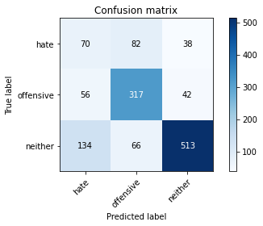

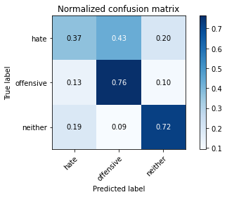

precision recall f1-score support

hate 0.27 0.37 0.31 190

offensive 0.68 0.76 0.72 415

neither 0.87 0.72 0.79 713

accuracy 0.68 1318

macro avg 0.61 0.62 0.61 1318

weighted avg 0.72 0.68 0.70 1318

average eval_loss: 1.4347778667103162, accuracy: 0.6828528072837633

3 run......

training 1 epoch...

95.88252091407776 seconds used......

1 training finished! average train loss: 1.5041650344025006

total clf loss: 146.95021536946297 total adv loss: 91.98304573446512

evaluating...

Confusion matrix, without normalization

[[ 13 101 76]

[ 9 359 47]

[ 5 89 619]]

Normalized confusion matrix

[[0.06842105 0.53157895 0.4 ]

[0.02168675 0.86506024 0.11325301]

[0.00701262 0.12482468 0.86816269]]

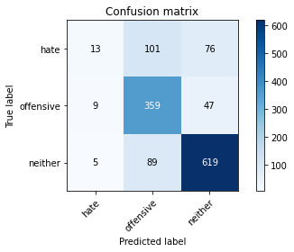

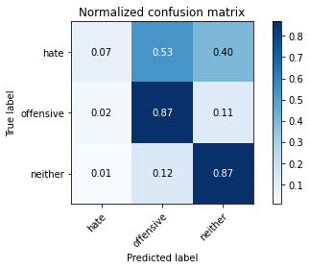

precision recall f1-score support

hate 0.48 0.07 0.12 190

offensive 0.65 0.87 0.74 415

neither 0.83 0.87 0.85 713

accuracy 0.75 1318

macro avg 0.66 0.60 0.57 1318

weighted avg 0.73 0.75 0.71 1318

average eval_loss: 0.615183302398884, accuracy: 0.7518968133535661

training 2 epoch...

95.71972703933716 seconds used......

2 training finished! average train loss: 1.062319572202184

total clf loss: 105.30185201764107 total adv loss: 64.20422721654177

evaluating...

Confusion matrix, without normalization

[[ 61 77 52]

[ 36 339 40]

[ 48 73 592]]

Normalized confusion matrix

[[0.32105263 0.40526316 0.27368421]

[0.08674699 0.81686747 0.09638554]

[0.06732118 0.10238429 0.83029453]]

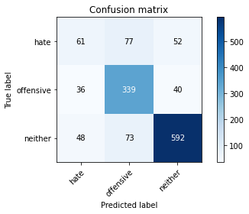

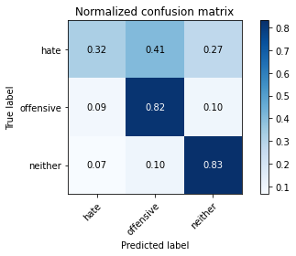

precision recall f1-score support

hate 0.42 0.32 0.36 190

offensive 0.69 0.82 0.75 415

neither 0.87 0.83 0.85 713

accuracy 0.75 1318

macro avg 0.66 0.66 0.65 1318

weighted avg 0.75 0.75 0.75 1318

average eval_loss: 0.6048759655518965, accuracy: 0.7526555386949925

training 3 epoch...

95.74000310897827 seconds used......

3 training finished! average train loss: 0.6778771799057722

total clf loss: 72.17025311663747 total adv loss: 38.4813632350415

evaluating...

Confusion matrix, without normalization

[[ 39 83 68]

[ 28 347 40]

[ 30 75 608]]

Normalized confusion matrix

[[0.20526316 0.43684211 0.35789474]

[0.06746988 0.83614458 0.09638554]

[0.04207574 0.10518934 0.85273492]]

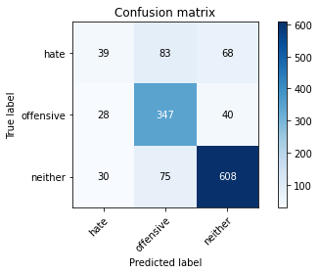

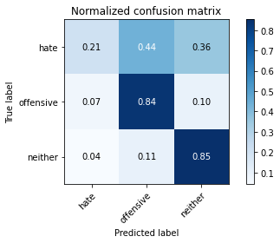

precision recall f1-score support

hate 0.40 0.21 0.27 190

offensive 0.69 0.84 0.75 415

neither 0.85 0.85 0.85 713

accuracy 0.75 1318

macro avg 0.65 0.63 0.63 1318

weighted avg 0.73 0.75 0.74 1318

average eval_loss: 0.7216003704251666, accuracy: 0.7541729893778453

training 4 epoch...

95.75397992134094 seconds used......

4 training finished! average train loss: 0.3501088386443867

total clf loss: 43.96796901267953 total adv loss: 16.52798772832375

evaluating...

Confusion matrix, without normalization

[[ 37 112 41]

[ 24 355 36]

[ 61 115 537]]

Normalized confusion matrix

[[0.19473684 0.58947368 0.21578947]

[0.05783133 0.85542169 0.08674699]

[0.085554 0.16129032 0.75315568]]

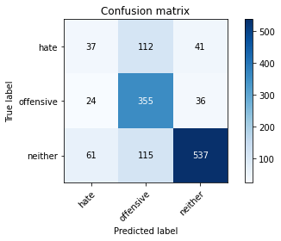

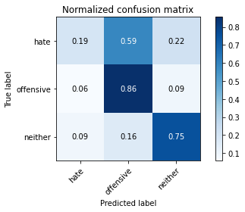

precision recall f1-score support

hate 0.30 0.19 0.24 190

offensive 0.61 0.86 0.71 415

neither 0.87 0.75 0.81 713

accuracy 0.70 1318

macro avg 0.60 0.60 0.59 1318

weighted avg 0.71 0.70 0.70 1318

average eval_loss: 1.023736931609385, accuracy: 0.704855842185129

training 5 epoch...

95.71583247184753 seconds used......

5 training finished! average train loss: 0.23629734751514414

total clf loss: 31.07861151592806 total adv loss: 10.453402427585388

evaluating...

Confusion matrix, without normalization

[[ 62 87 41]

[ 44 341 30]

[103 82 528]]

Normalized confusion matrix

[[0.32631579 0.45789474 0.21578947]

[0.1060241 0.82168675 0.07228916]

[0.14446003 0.11500701 0.74053296]]

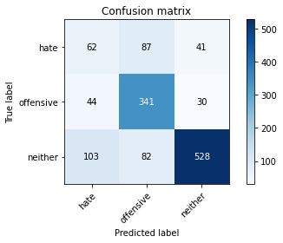

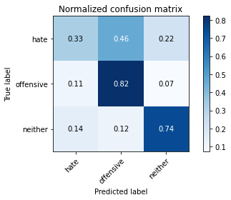

precision recall f1-score support

hate 0.30 0.33 0.31 190

offensive 0.67 0.82 0.74 415

neither 0.88 0.74 0.80 713

accuracy 0.71 1318

macro avg 0.62 0.63 0.62 1318

weighted avg 0.73 0.71 0.71 1318

average eval_loss: 1.0295042458808783, accuracy: 0.7063732928679818

training 6 epoch...

95.7568039894104 seconds used......

6 training finished! average train loss: 0.13430668563920667

total clf loss: 18.66586497798562 total adv loss: 5.440802889869701

evaluating...

Confusion matrix, without normalization

[[ 40 75 75]

[ 39 311 65]

[ 51 51 611]]

Normalized confusion matrix

[[0.21052632 0.39473684 0.39473684]

[0.0939759 0.74939759 0.15662651]

[0.07152875 0.07152875 0.8569425 ]]

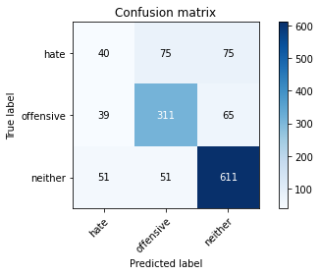

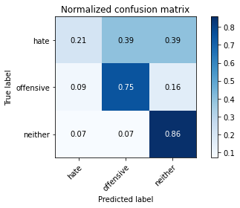

precision recall f1-score support

hate 0.31 0.21 0.25 190

offensive 0.71 0.75 0.73 415

neither 0.81 0.86 0.83 713

accuracy 0.73 1318

macro avg 0.61 0.61 0.60 1318

weighted avg 0.71 0.73 0.72 1318

average eval_loss: 1.059682615778663, accuracy: 0.7298937784522003

training 7 epoch...

95.73838496208191 seconds used......

7 training finished! average train loss: 0.11368260101368254

total clf loss: 14.008217397655244 total adv loss: 5.50097741807167

evaluating...

Confusion matrix, without normalization

[[ 61 67 62]

[ 61 307 47]

[ 81 42 590]]

Normalized confusion matrix

[[0.32105263 0.35263158 0.32631579]

[0.14698795 0.73975904 0.11325301]

[0.11360449 0.05890603 0.82748948]]

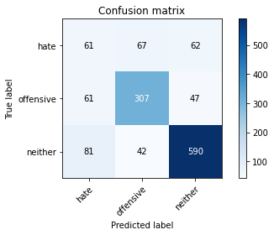

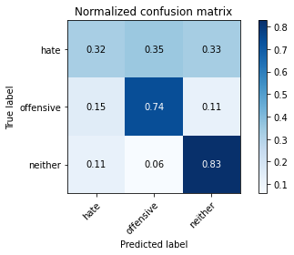

precision recall f1-score support

hate 0.30 0.32 0.31 190

offensive 0.74 0.74 0.74 415

neither 0.84 0.83 0.84 713

accuracy 0.73 1318

macro avg 0.63 0.63 0.63 1318

weighted avg 0.73 0.73 0.73 1318

average eval_loss: 1.1196639975815108, accuracy: 0.7268588770864947

training 8 epoch...

95.76262283325195 seconds used......

8 training finished! average train loss: 0.09101292100914923

total clf loss: 10.010940120904706 total adv loss: 5.0059513018713915

evaluating...

Confusion matrix, without normalization

[[ 55 99 36]

[ 43 346 26]

[123 99 491]]

Normalized confusion matrix

[[0.28947368 0.52105263 0.18947368]

[0.10361446 0.83373494 0.0626506 ]

[0.17251052 0.13884993 0.68863955]]

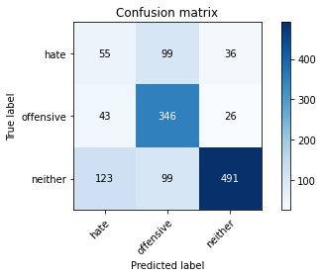

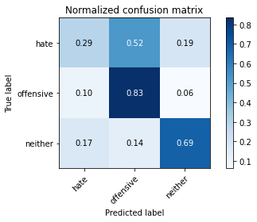

precision recall f1-score support

hate 0.25 0.29 0.27 190

offensive 0.64 0.83 0.72 415

neither 0.89 0.69 0.78 713

accuracy 0.68 1318

macro avg 0.59 0.60 0.59 1318

weighted avg 0.72 0.68 0.69 1318

average eval_loss: 1.4017435601263335, accuracy: 0.6767830045523521

training 9 epoch...

95.81126093864441 seconds used......

9 training finished! average train loss: 0.08723865137924969

total clf loss: 9.039342067786492 total adv loss: 5.076580679073231

evaluating...

Confusion matrix, without normalization

[[ 52 86 52]

[ 44 327 44]

[ 81 73 559]]

Normalized confusion matrix

[[0.27368421 0.45263158 0.27368421]

[0.1060241 0.78795181 0.1060241 ]

[0.11360449 0.10238429 0.78401122]]

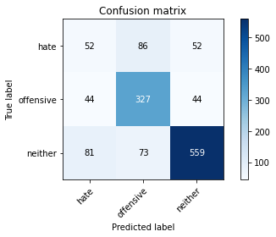

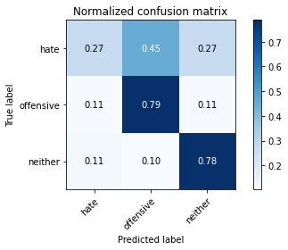

precision recall f1-score support

hate 0.29 0.27 0.28 190

offensive 0.67 0.79 0.73 415

neither 0.85 0.78 0.82 713

accuracy 0.71 1318

macro avg 0.61 0.62 0.61 1318

weighted avg 0.72 0.71 0.71 1318

average eval_loss: 1.261153636556683, accuracy: 0.7116843702579666

training 10 epoch...

95.74490308761597 seconds used......

10 training finished! average train loss: 0.05339010669135446

total clf loss: 6.321804135688581 total adv loss: 2.7120096525519557

evaluating...

Confusion matrix, without normalization

[[ 44 113 33]

[ 35 356 24]

[ 99 122 492]]

Normalized confusion matrix

[[0.23157895 0.59473684 0.17368421]

[0.08433735 0.85783133 0.05783133]

[0.13884993 0.17110799 0.69004208]]

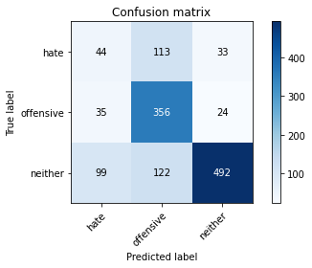

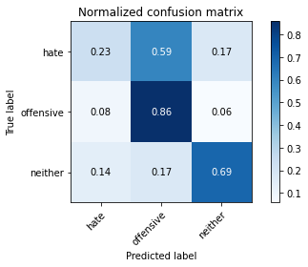

precision recall f1-score support

hate 0.25 0.23 0.24 190

offensive 0.60 0.86 0.71 415

neither 0.90 0.69 0.78 713

accuracy 0.68 1318

macro avg 0.58 0.59 0.58 1318

weighted avg 0.71 0.68 0.68 1318

average eval_loss: 1.531663819695964, accuracy: 0.6767830045523521

4 run......

training 1 epoch...

95.7014217376709 seconds used......

1 training finished! average train loss: 1.517299209399657

total clf loss: 147.60728216171265 total adv loss: 93.09927202761173

evaluating...

Confusion matrix, without normalization

[[ 49 62 79]

[ 23 304 88]

[ 30 29 654]]

Normalized confusion matrix

[[0.25789474 0.32631579 0.41578947]

[0.05542169 0.73253012 0.21204819]

[0.04207574 0.04067321 0.91725105]]

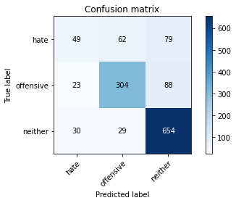

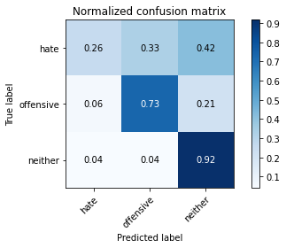

precision recall f1-score support

hate 0.48 0.26 0.34 190

offensive 0.77 0.73 0.75 415

neither 0.80 0.92 0.85 713

accuracy 0.76 1318

macro avg 0.68 0.64 0.65 1318

weighted avg 0.74 0.76 0.75 1318

average eval_loss: 0.592993946689548, accuracy: 0.7640364188163885

training 2 epoch...

95.7302622795105 seconds used......

2 training finished! average train loss: 1.0765535569072446

total clf loss: 106.61028086859733 total adv loss: 65.11575104150688

evaluating...

Confusion matrix, without normalization

[[ 16 97 77]

[ 7 350 58]

[ 14 74 625]]

Normalized confusion matrix

[[0.08421053 0.51052632 0.40526316]

[0.01686747 0.84337349 0.13975904]

[0.01963534 0.10378682 0.87657784]]

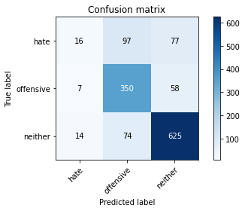

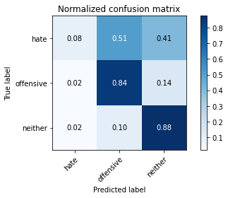

precision recall f1-score support

hate 0.43 0.08 0.14 190

offensive 0.67 0.84 0.75 415

neither 0.82 0.88 0.85 713

accuracy 0.75 1318

macro avg 0.64 0.60 0.58 1318

weighted avg 0.72 0.75 0.71 1318

average eval_loss: 0.6230666095560248, accuracy: 0.7518968133535661

training 3 epoch...

95.69347333908081 seconds used......

3 training finished! average train loss: 0.720428393167359

total clf loss: 76.32899797707796 total adv loss: 41.082624235743424

evaluating...

Confusion matrix, without normalization

[[ 87 73 30]

[ 40 348 27]

[122 78 513]]

Normalized confusion matrix

[[0.45789474 0.38421053 0.15789474]

[0.09638554 0.83855422 0.06506024]

[0.17110799 0.10939691 0.71949509]]

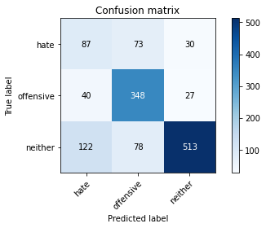

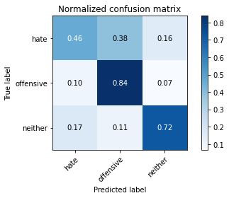

precision recall f1-score support

hate 0.35 0.46 0.40 190

offensive 0.70 0.84 0.76 415

neither 0.90 0.72 0.80 713

accuracy 0.72 1318

macro avg 0.65 0.67 0.65 1318

weighted avg 0.76 0.72 0.73 1318

average eval_loss: 0.7672536716316686, accuracy: 0.7192716236722306

training 4 epoch...

95.65834283828735 seconds used......

4 training finished! average train loss: 0.3986026463606818

total clf loss: 48.1045984365046 total adv loss: 19.793991875689244

evaluating...

Confusion matrix, without normalization

[[ 64 81 45]

[ 38 333 44]

[ 75 87 551]]

Normalized confusion matrix

[[0.33684211 0.42631579 0.23684211]

[0.09156627 0.80240964 0.1060241 ]

[0.10518934 0.12201964 0.77279102]]

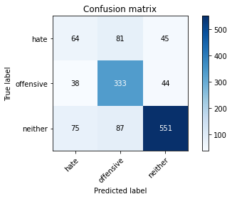

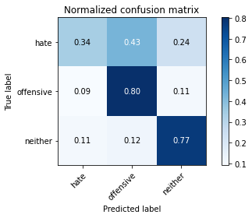

precision recall f1-score support

hate 0.36 0.34 0.35 190

offensive 0.66 0.80 0.73 415

neither 0.86 0.77 0.81 713

accuracy 0.72 1318

macro avg 0.63 0.64 0.63 1318

weighted avg 0.73 0.72 0.72 1318

average eval_loss: 0.8348551033572718, accuracy: 0.7192716236722306

training 5 epoch...

95.69936847686768 seconds used......

5 training finished! average train loss: 0.23179526158015837

total clf loss: 31.474981917999685 total adv loss: 9.759987744859245

evaluating...

Confusion matrix, without normalization

[[ 46 82 62]

[ 31 331 53]

[ 67 58 588]]

Normalized confusion matrix

[[0.24210526 0.43157895 0.32631579]

[0.0746988 0.79759036 0.12771084]

[0.09396914 0.08134642 0.82468443]]

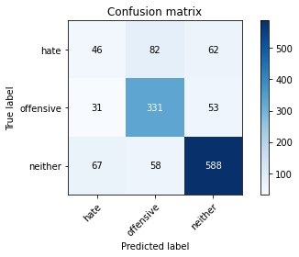

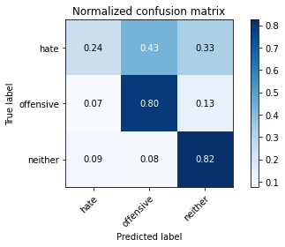

precision recall f1-score support

hate 0.32 0.24 0.28 190

offensive 0.70 0.80 0.75 415

neither 0.84 0.82 0.83 713

accuracy 0.73 1318

macro avg 0.62 0.62 0.62 1318

weighted avg 0.72 0.73 0.72 1318

average eval_loss: 0.9629386744715951, accuracy: 0.7321699544764795

training 6 epoch...

95.72786355018616 seconds used......

6 training finished! average train loss: 0.1710691784635525

total clf loss: 22.610580402892083 total adv loss: 7.512319379318797

evaluating...

Confusion matrix, without normalization

[[ 96 66 28]

[ 72 314 29]

[170 57 486]]

Normalized confusion matrix

[[0.50526316 0.34736842 0.14736842]

[0.17349398 0.75662651 0.06987952]

[0.23842917 0.0799439 0.68162693]]

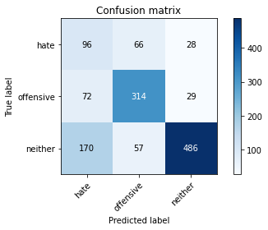

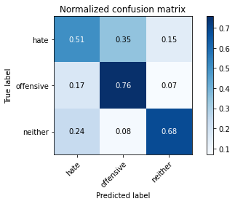

precision recall f1-score support

hate 0.28 0.51 0.36 190

offensive 0.72 0.76 0.74 415

neither 0.90 0.68 0.77 713

accuracy 0.68 1318

macro avg 0.63 0.65 0.62 1318

weighted avg 0.75 0.68 0.70 1318

average eval_loss: 1.1185408532619476, accuracy: 0.6798179059180577

training 7 epoch...

95.72283864021301 seconds used......

7 training finished! average train loss: 0.12120218643791635

total clf loss: 15.133035738253966 total adv loss: 5.76572263822527

evaluating...

Confusion matrix, without normalization

[[ 53 81 56]

[ 43 332 40]

[104 69 540]]

Normalized confusion matrix

[[0.27894737 0.42631579 0.29473684]

[0.10361446 0.8 0.09638554]

[0.14586255 0.09677419 0.75736325]]

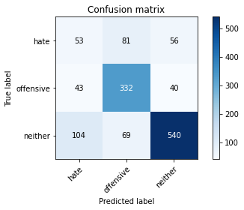

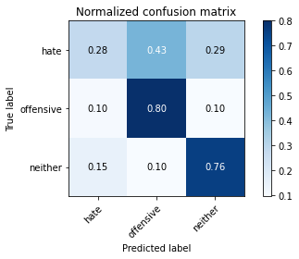

precision recall f1-score support

hate 0.27 0.28 0.27 190

offensive 0.69 0.80 0.74 415

neither 0.85 0.76 0.80 713

accuracy 0.70 1318

macro avg 0.60 0.61 0.60 1318

weighted avg 0.71 0.70 0.71 1318

average eval_loss: 1.1499831947413357, accuracy: 0.7018209408194234

training 8 epoch...

95.69556331634521 seconds used......

8 training finished! average train loss: 0.06663827158203772

total clf loss: 9.052991862175986 total adv loss: 2.803713930572485

evaluating...

Confusion matrix, without normalization

[[ 92 60 38]

[ 70 308 37]

[164 45 504]]

Normalized confusion matrix

[[0.48421053 0.31578947 0.2 ]

[0.1686747 0.74216867 0.08915663]

[0.23001403 0.0631136 0.70687237]]

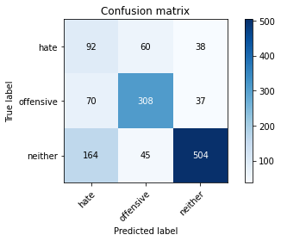

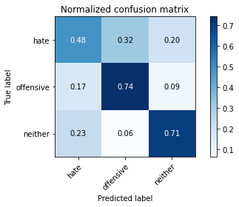

precision recall f1-score support

hate 0.28 0.48 0.36 190

offensive 0.75 0.74 0.74 415

neither 0.87 0.71 0.78 713

accuracy 0.69 1318

macro avg 0.63 0.64 0.63 1318

weighted avg 0.75 0.69 0.71 1318

average eval_loss: 1.296229382581783, accuracy: 0.6858877086494689

training 9 epoch...

95.64026427268982 seconds used......

9 training finished! average train loss: 0.09008300951682031

total clf loss: 8.988724883907707 total adv loss: 5.4147686509149935

evaluating...

Confusion matrix, without normalization

[[ 47 88 55]

[ 35 334 46]

[ 86 70 557]]

Normalized confusion matrix

[[0.24736842 0.46315789 0.28947368]

[0.08433735 0.80481928 0.11084337]

[0.12061711 0.09817672 0.78120617]]

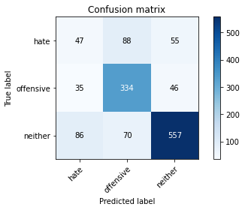

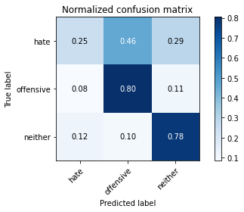

precision recall f1-score support

hate 0.28 0.25 0.26 190

offensive 0.68 0.80 0.74 415

neither 0.85 0.78 0.81 713

accuracy 0.71 1318

macro avg 0.60 0.61 0.60 1318

weighted avg 0.71 0.71 0.71 1318

average eval_loss: 1.2628432354240706, accuracy: 0.7116843702579666

training 10 epoch...

95.68845176696777 seconds used......

10 training finished! average train loss: 0.046212561856373215

total clf loss: 5.829537693585735 total adv loss: 2.168612954729724

evaluating...

Confusion matrix, without normalization

[[ 69 72 49]

[ 52 308 55]

[107 50 556]]

Normalized confusion matrix

[[0.36315789 0.37894737 0.25789474]

[0.1253012 0.74216867 0.13253012]

[0.15007013 0.07012623 0.77980365]]

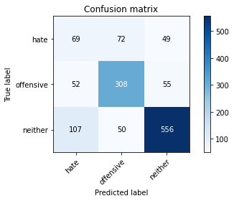

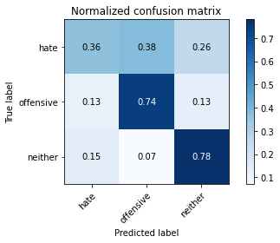

precision recall f1-score support

hate 0.30 0.36 0.33 190

offensive 0.72 0.74 0.73 415

neither 0.84 0.78 0.81 713

accuracy 0.71 1318

macro avg 0.62 0.63 0.62 1318

weighted avg 0.72 0.71 0.72 1318

average eval_loss: 1.3826979516130504, accuracy: 0.7078907435508346

5 run......

training 1 epoch...

95.67464804649353 seconds used......

1 training finished! average train loss: 1.5053587983955037

total clf loss: 148.22948394715786 total adv loss: 91.47472594678402

evaluating...

Confusion matrix, without normalization

[[ 54 84 52]

[ 29 326 60]

[ 50 48 615]]

Normalized confusion matrix

[[0.28421053 0.44210526 0.27368421]

[0.06987952 0.78554217 0.14457831]

[0.07012623 0.06732118 0.86255259]]

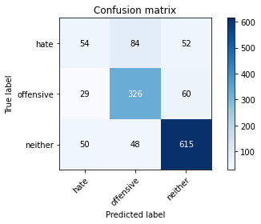

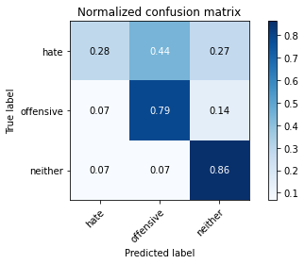

precision recall f1-score support

hate 0.41 0.28 0.33 190

offensive 0.71 0.79 0.75 415

neither 0.85 0.86 0.85 713

accuracy 0.75 1318

macro avg 0.65 0.64 0.65 1318

weighted avg 0.74 0.75 0.75 1318

average eval_loss: 0.5985524600202387, accuracy: 0.7549317147192717

training 2 epoch...

95.57532286643982 seconds used......

2 training finished! average train loss: 1.0668885197151792

total clf loss: 106.85138066112995 total adv loss: 63.9320466183126

evaluating...

Confusion matrix, without normalization

[[ 33 104 53]

[ 13 360 42]

[ 28 94 591]]

Normalized confusion matrix

[[0.17368421 0.54736842 0.27894737]

[0.0313253 0.86746988 0.10120482]

[0.03927069 0.13183731 0.82889201]]

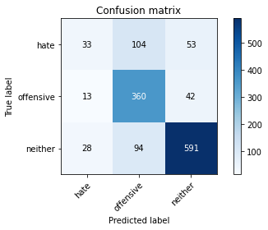

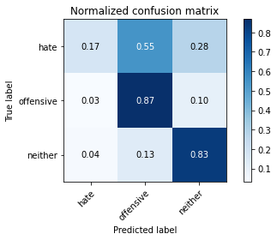

precision recall f1-score support

hate 0.45 0.17 0.25 190

offensive 0.65 0.87 0.74 415

neither 0.86 0.83 0.84 713

accuracy 0.75 1318

macro avg 0.65 0.62 0.61 1318

weighted avg 0.73 0.75 0.73 1318

average eval_loss: 0.6285256219632698, accuracy: 0.7465857359635811

training 3 epoch...

95.68038034439087 seconds used......

3 training finished! average train loss: 0.75419929867441

total clf loss: 79.79532278329134 total adv loss: 43.064261658117175

evaluating...

Confusion matrix, without normalization

[[ 68 59 63]

[ 41 307 67]

[ 58 35 620]]

Normalized confusion matrix

[[0.35789474 0.31052632 0.33157895]

[0.09879518 0.73975904 0.16144578]

[0.08134642 0.04908836 0.86956522]]

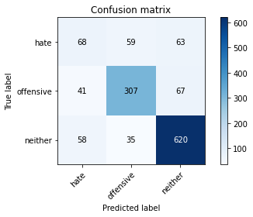

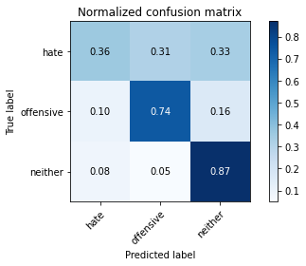

precision recall f1-score support

hate 0.41 0.36 0.38 190

offensive 0.77 0.74 0.75 415

neither 0.83 0.87 0.85 713

accuracy 0.75 1318

macro avg 0.67 0.66 0.66 1318

weighted avg 0.75 0.75 0.75 1318

average eval_loss: 0.6702827050378828, accuracy: 0.7549317147192717

training 4 epoch...

95.66838717460632 seconds used......

4 training finished! average train loss: 0.4102078798311678

total clf loss: 49.87699046358466 total adv loss: 20.184371619077865

evaluating...

Confusion matrix, without normalization

[[ 95 52 43]

[ 71 292 52]

[117 38 558]]

Normalized confusion matrix

[[0.5 0.27368421 0.22631579]

[0.17108434 0.70361446 0.1253012 ]

[0.16409537 0.05329593 0.7826087 ]]

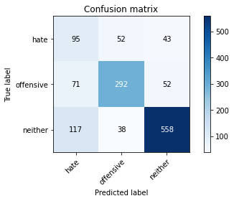

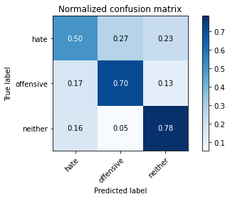

precision recall f1-score support

hate 0.34 0.50 0.40 190

offensive 0.76 0.70 0.73 415

neither 0.85 0.78 0.82 713

accuracy 0.72 1318

macro avg 0.65 0.66 0.65 1318

weighted avg 0.75 0.72 0.73 1318

average eval_loss: 0.8152489847306049, accuracy: 0.7169954476479514

training 5 epoch...

95.63575911521912 seconds used......

5 training finished! average train loss: 0.2725685890256004

total clf loss: 34.388706896454096 total adv loss: 12.788191211497178

evaluating...

Confusion matrix, without normalization

[[ 57 80 53]

[ 48 317 50]

[ 84 66 563]]

Normalized confusion matrix

[[0.3 0.42105263 0.27894737]

[0.11566265 0.76385542 0.12048193]

[0.11781206 0.09256662 0.78962132]]

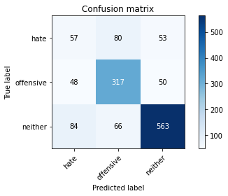

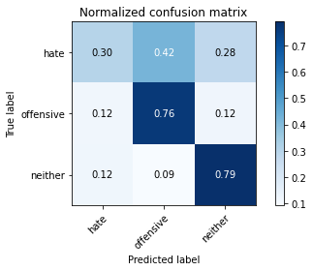

precision recall f1-score support

hate 0.30 0.30 0.30 190

offensive 0.68 0.76 0.72 415

neither 0.85 0.79 0.82 713

accuracy 0.71 1318

macro avg 0.61 0.62 0.61 1318

weighted avg 0.72 0.71 0.71 1318

average eval_loss: 0.9720050259069963, accuracy: 0.7109256449165402

training 6 epoch...

95.69306492805481 seconds used......

6 training finished! average train loss: 0.15973777937364173

total clf loss: 21.725821294356138 total adv loss: 6.708245079502376

evaluating...

Confusion matrix, without normalization

[[100 56 34]

[ 86 289 40]

[149 41 523]]

Normalized confusion matrix

[[0.52631579 0.29473684 0.17894737]

[0.20722892 0.69638554 0.09638554]

[0.20897616 0.05750351 0.73352034]]

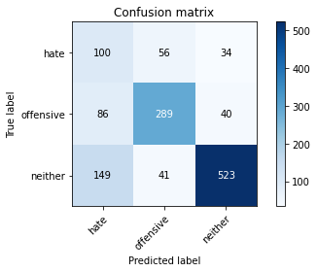

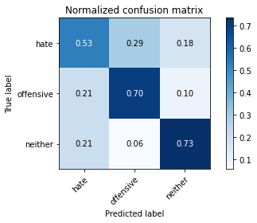

precision recall f1-score support

hate 0.30 0.53 0.38 190

offensive 0.75 0.70 0.72 415

neither 0.88 0.73 0.80 713

accuracy 0.69 1318

macro avg 0.64 0.65 0.63 1318

weighted avg 0.75 0.69 0.71 1318

average eval_loss: 1.1000955231261975, accuracy: 0.6919575113808801

training 7 epoch...

95.66307950019836 seconds used......

7 training finished! average train loss: 0.09736091033343904

total clf loss: 13.818719806382433 total adv loss: 3.800340277894975

evaluating...

Confusion matrix, without normalization

[[ 71 80 39]

[ 54 322 39]

[137 69 507]]

Normalized confusion matrix

[[0.37368421 0.42105263 0.20526316]

[0.13012048 0.77590361 0.0939759 ]

[0.19214586 0.09677419 0.71107994]]

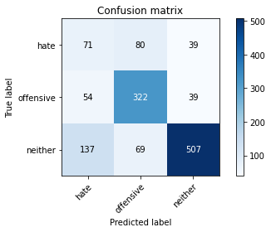

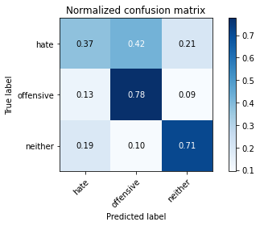

precision recall f1-score support

hate 0.27 0.37 0.31 190

offensive 0.68 0.78 0.73 415

neither 0.87 0.71 0.78 713

accuracy 0.68 1318

macro avg 0.61 0.62 0.61 1318

weighted avg 0.72 0.68 0.70 1318

average eval_loss: 1.2462880471439073, accuracy: 0.6828528072837633

training 8 epoch...

95.68457913398743 seconds used......

8 training finished! average train loss: 0.10465293395100161

total clf loss: 11.69851581635885 total adv loss: 5.66256480384618

evaluating...

Confusion matrix, without normalization

[[ 63 73 54]

[ 40 323 52]

[103 41 569]]

Normalized confusion matrix

[[0.33157895 0.38421053 0.28421053]

[0.09638554 0.77831325 0.1253012 ]

[0.14446003 0.05750351 0.79803647]]

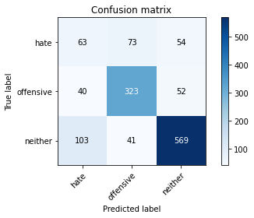

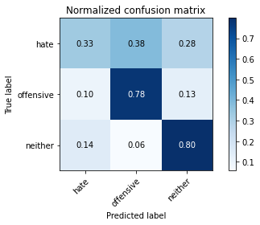

precision recall f1-score support

hate 0.31 0.33 0.32 190

offensive 0.74 0.78 0.76 415

neither 0.84 0.80 0.82 713

accuracy 0.72 1318

macro avg 0.63 0.64 0.63 1318

weighted avg 0.73 0.72 0.73 1318

average eval_loss: 1.1529523233572643, accuracy: 0.7245827010622155

training 9 epoch...

95.68817162513733 seconds used......

9 training finished! average train loss: 0.06524748577715152

total clf loss: 6.745864551747218 total adv loss: 3.8042910752388934

evaluating...

Confusion matrix, without normalization

[[ 71 74 45]

[ 56 319 40]

[124 59 530]]

Normalized confusion matrix

[[0.37368421 0.38947368 0.23684211]

[0.13493976 0.7686747 0.09638554]

[0.17391304 0.08274895 0.74333801]]

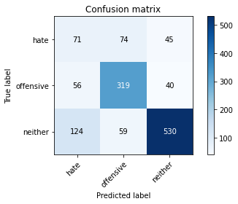

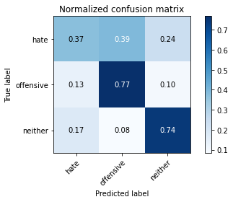

precision recall f1-score support

hate 0.28 0.37 0.32 190

offensive 0.71 0.77 0.74 415

neither 0.86 0.74 0.80 713

accuracy 0.70 1318

macro avg 0.62 0.63 0.62 1318

weighted avg 0.73 0.70 0.71 1318

average eval_loss: 1.3821143115108663, accuracy: 0.6980273141122914

training 10 epoch...

95.70257496833801 seconds used......

10 training finished! average train loss: 0.06486007726277669

total clf loss: 7.332614724859013 total adv loss: 3.468301096720097

evaluating...

Confusion matrix, without normalization

[[ 61 98 31]

[ 41 345 29]

[130 95 488]]

Normalized confusion matrix

[[0.32105263 0.51578947 0.16315789]

[0.09879518 0.8313253 0.06987952]

[0.18232819 0.13323983 0.68443198]]

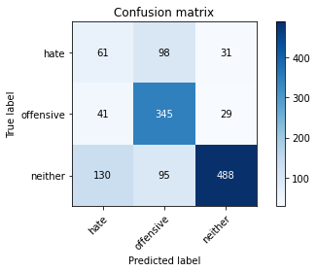

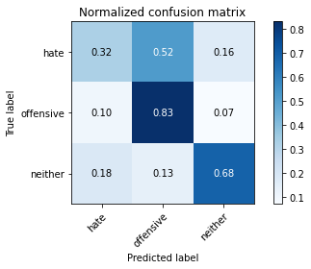

precision recall f1-score support

hate 0.26 0.32 0.29 190

offensive 0.64 0.83 0.72 415

neither 0.89 0.68 0.77 713

accuracy 0.68 1318

macro avg 0.60 0.61 0.60 1318

weighted avg 0.72 0.68 0.69 1318

average eval_loss: 1.5889643692609035, accuracy: 0.6783004552352049

1 run......

training 1 epoch...

95.71502637863159 seconds used......

1 training finished! average train loss: 1.5002626082436605

total clf loss: 146.72462893649936 total adv loss: 91.66657241433859

evaluating...

Confusion matrix, without normalization

[[ 55 61 74]

[ 28 309 78]

[ 28 39 646]]

Normalized confusion matrix

[[0.28947368 0.32105263 0.38947368]

[0.06746988 0.74457831 0.18795181]

[0.03927069 0.05469846 0.90603086]]

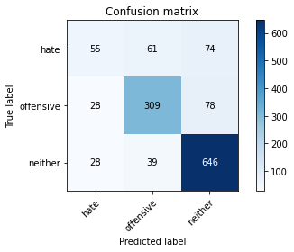

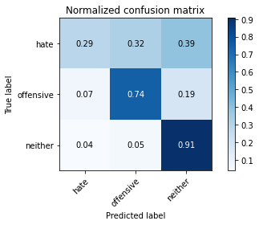

precision recall f1-score support

hate 0.50 0.29 0.37 190

offensive 0.76 0.74 0.75 415

neither 0.81 0.91 0.86 713

accuracy 0.77 1318

macro avg 0.69 0.65 0.66 1318

weighted avg 0.75 0.77 0.75 1318

average eval_loss: 0.5846965191039172, accuracy: 0.7663125948406677

training 2 epoch...

95.64992022514343 seconds used......

2 training finished! average train loss: 1.0778630658984185

total clf loss: 107.28962348774076 total adv loss: 64.92012530192733

evaluating...

Confusion matrix, without normalization

[[103 57 30]

[ 70 322 23]

[129 61 523]]

Normalized confusion matrix

[[0.54210526 0.3 0.15789474]

[0.1686747 0.77590361 0.05542169]

[0.18092567 0.085554 0.73352034]]

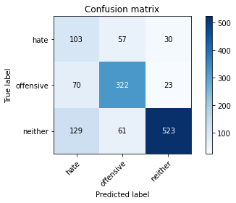

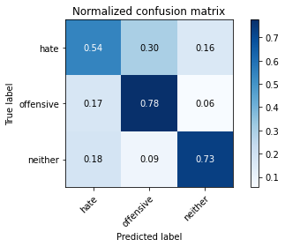

precision recall f1-score support

hate 0.34 0.54 0.42 190

offensive 0.73 0.78 0.75 415

neither 0.91 0.73 0.81 713

accuracy 0.72 1318

macro avg 0.66 0.68 0.66 1318

weighted avg 0.77 0.72 0.74 1318

average eval_loss: 0.6807766443852222, accuracy: 0.7192716236722306

training 3 epoch...

95.64735245704651 seconds used......

3 training finished! average train loss: 0.7203317611732266

total clf loss: 76.78167500346899 total adv loss: 40.84565648622811

evaluating...

Confusion matrix, without normalization

[[ 95 48 47]

[ 75 286 54]

[ 83 40 590]]

Normalized confusion matrix

[[0.5 0.25263158 0.24736842]

[0.18072289 0.68915663 0.13012048]

[0.11640954 0.05610098 0.82748948]]

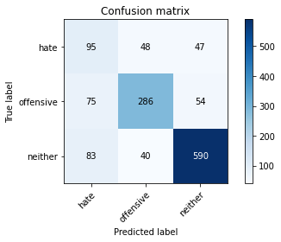

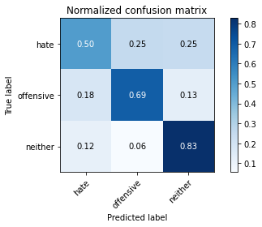

precision recall f1-score support

hate 0.38 0.50 0.43 190

offensive 0.76 0.69 0.72 415

neither 0.85 0.83 0.84 713

accuracy 0.74 1318

macro avg 0.66 0.67 0.66 1318

weighted avg 0.76 0.74 0.74 1318

average eval_loss: 0.6618631446000302, accuracy: 0.7367223065250379

training 4 epoch...

95.64345192909241 seconds used......

4 training finished! average train loss: 0.42510348734530534

total clf loss: 51.0722630918026 total adv loss: 21.225252009229735

evaluating...

Confusion matrix, without normalization

[[ 92 62 36]

[ 78 301 36]

[124 50 539]]

Normalized confusion matrix

[[0.48421053 0.32631579 0.18947368]

[0.18795181 0.7253012 0.08674699]

[0.17391304 0.07012623 0.75596073]]

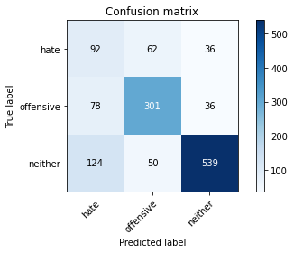

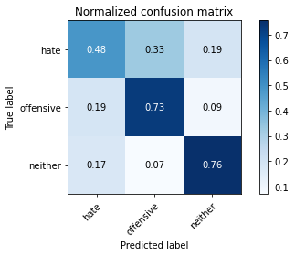

precision recall f1-score support

hate 0.31 0.48 0.38 190

offensive 0.73 0.73 0.73 415

neither 0.88 0.76 0.81 713

accuracy 0.71 1318

macro avg 0.64 0.66 0.64 1318

weighted avg 0.75 0.71 0.72 1318

average eval_loss: 0.8314434666976784, accuracy: 0.7071320182094082

training 5 epoch...

95.60086846351624 seconds used......

5 training finished! average train loss: 0.25945446510714565

total clf loss: 34.37014178931713 total adv loss: 11.354920257857884

evaluating...

Confusion matrix, without normalization

[[ 70 72 48]

[ 39 332 44]

[ 79 82 552]]

Normalized confusion matrix

[[0.36842105 0.37894737 0.25263158]

[0.0939759 0.8 0.1060241 ]

[0.11079944 0.11500701 0.77419355]]

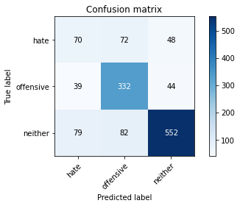

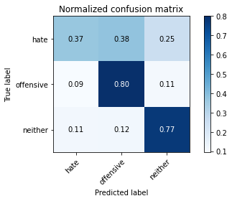

precision recall f1-score support

hate 0.37 0.37 0.37 190

offensive 0.68 0.80 0.74 415

neither 0.86 0.77 0.81 713

accuracy 0.72 1318

macro avg 0.64 0.65 0.64 1318

weighted avg 0.73 0.72 0.73 1318

average eval_loss: 0.9802868494933302, accuracy: 0.723823975720789

training 6 epoch...

95.6266508102417 seconds used......

6 training finished! average train loss: 0.1590946143874052

total clf loss: 22.02446399629116 total adv loss: 6.488175606747973

evaluating...

Confusion matrix, without normalization

[[ 56 85 49]

[ 43 337 35]

[ 64 88 561]]

Normalized confusion matrix

[[0.29473684 0.44736842 0.25789474]

[0.10361446 0.81204819 0.08433735]

[0.08976157 0.12342216 0.78681627]]

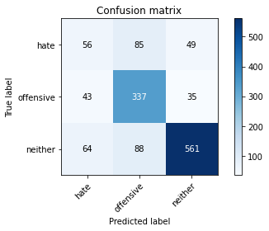

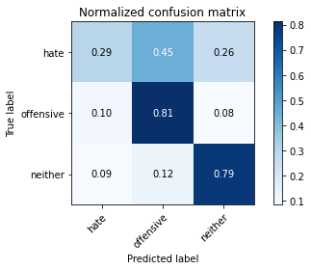

precision recall f1-score support

hate 0.34 0.29 0.32 190

offensive 0.66 0.81 0.73 415

neither 0.87 0.79 0.83 713

accuracy 0.72 1318

macro avg 0.62 0.63 0.62 1318

weighted avg 0.73 0.72 0.72 1318

average eval_loss: 1.0276641212403774, accuracy: 0.723823975720789

training 7 epoch...

95.69628810882568 seconds used......

7 training finished! average train loss: 0.11904161530123515

total clf loss: 15.366615761537105 total adv loss: 5.411269777090638

evaluating...

Confusion matrix, without normalization

[[ 52 87 51]

[ 33 344 38]

[ 70 85 558]]

Normalized confusion matrix

[[0.27368421 0.45789474 0.26842105]

[0.07951807 0.82891566 0.09156627]

[0.09817672 0.11921459 0.7826087 ]]

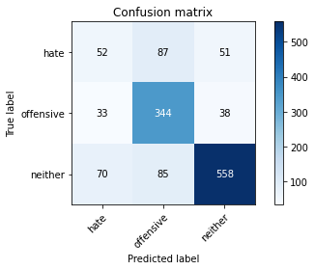

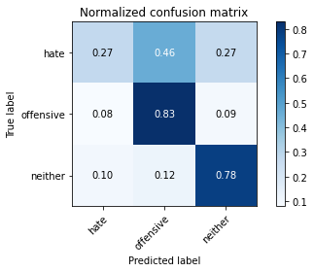

precision recall f1-score support

hate 0.34 0.27 0.30 190

offensive 0.67 0.83 0.74 415

neither 0.86 0.78 0.82 713

accuracy 0.72 1318

macro avg 0.62 0.63 0.62 1318

weighted avg 0.72 0.72 0.72 1318

average eval_loss: 1.1626530314485233, accuracy: 0.723823975720789

training 8 epoch...

95.72401332855225 seconds used......

8 training finished! average train loss: 0.08345936276759444

total clf loss: 9.867765933973715 total adv loss: 4.246646914669327

evaluating...

Confusion matrix, without normalization

[[ 87 62 41]

[ 69 311 35]

[133 46 534]]

Normalized confusion matrix

[[0.45789474 0.32631579 0.21578947]

[0.16626506 0.74939759 0.08433735]

[0.18653576 0.06451613 0.74894811]]

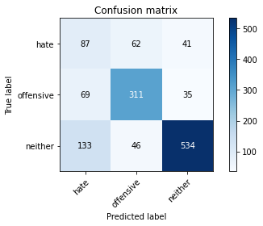

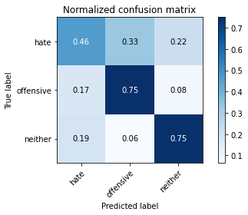

precision recall f1-score support

hate 0.30 0.46 0.36 190

offensive 0.74 0.75 0.75 415

neither 0.88 0.75 0.81 713

accuracy 0.71 1318

macro avg 0.64 0.65 0.64 1318

weighted avg 0.75 0.71 0.72 1318

average eval_loss: 1.2030451401616589, accuracy: 0.7071320182094082

training 9 epoch...

95.69438600540161 seconds used......

9 training finished! average train loss: 0.0632037591083314

total clf loss: 6.832429841684643 total adv loss: 3.5361985816095967

evaluating...

Confusion matrix, without normalization

[[ 56 81 53]

[ 38 340 37]

[ 76 82 555]]

Normalized confusion matrix

[[0.29473684 0.42631579 0.27894737]

[0.09156627 0.81927711 0.08915663]

[0.10659187 0.11500701 0.77840112]]

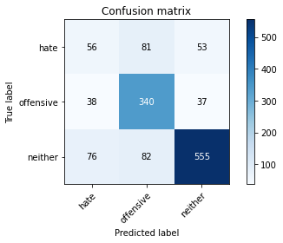

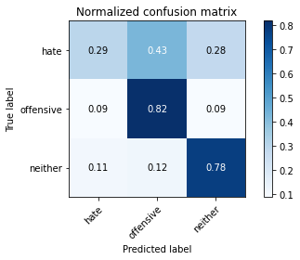

precision recall f1-score support

hate 0.33 0.29 0.31 190

offensive 0.68 0.82 0.74 415

neither 0.86 0.78 0.82 713

accuracy 0.72 1318

macro avg 0.62 0.63 0.62 1318

weighted avg 0.73 0.72 0.72 1318

average eval_loss: 1.321847831886826, accuracy: 0.7215477996965098

training 10 epoch...

95.72696709632874 seconds used......

10 training finished! average train loss: 0.059623637708864405

total clf loss: 6.192921069625299 total adv loss: 3.462139604582262

evaluating...

Confusion matrix, without normalization

[[ 75 63 52]

[ 62 306 47]

[108 43 562]]

Normalized confusion matrix

[[0.39473684 0.33157895 0.27368421]

[0.14939759 0.7373494 0.11325301]

[0.15147265 0.06030856 0.78821879]]

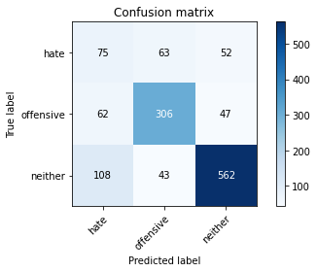

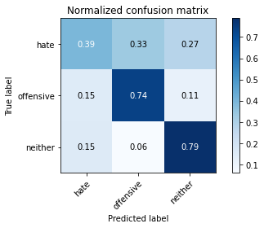

precision recall f1-score support

hate 0.31 0.39 0.34 190

offensive 0.74 0.74 0.74 415

neither 0.85 0.79 0.82 713

accuracy 0.72 1318

macro avg 0.63 0.64 0.63 1318

weighted avg 0.74 0.72 0.73 1318

average eval_loss: 1.2679862249078173, accuracy: 0.7154779969650986